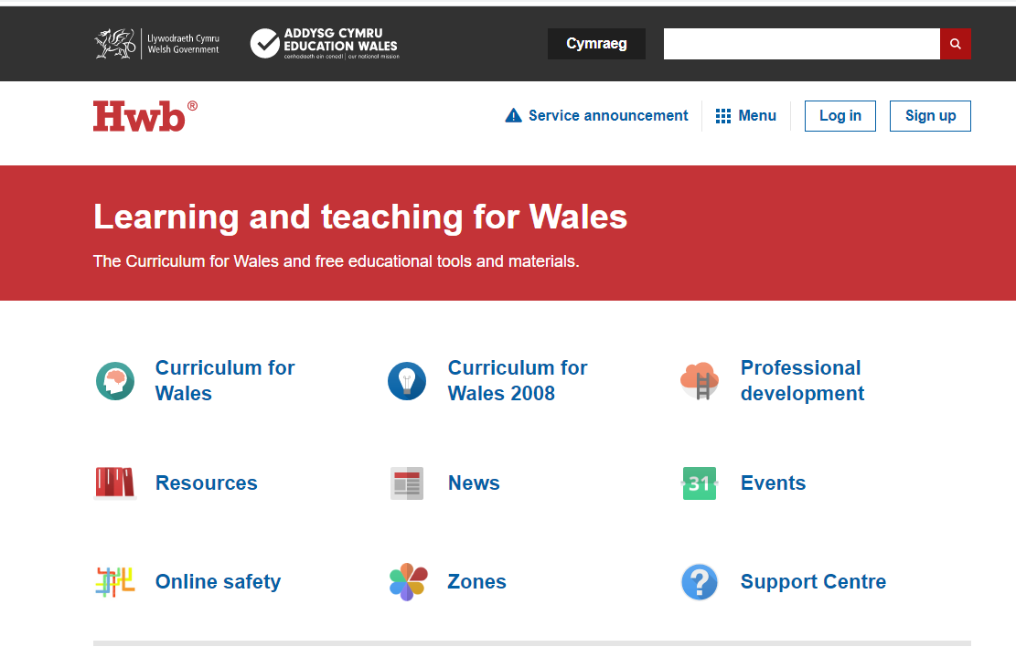
How to access Google Classrooms
Go to Hwb home page and Log In.

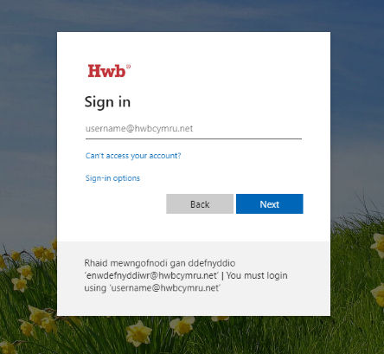
Enter Hwb log in details. These can be found in the front of the Work books that were sent home.

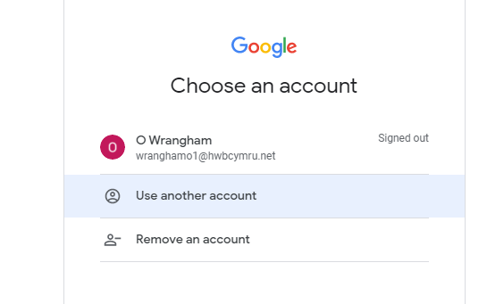
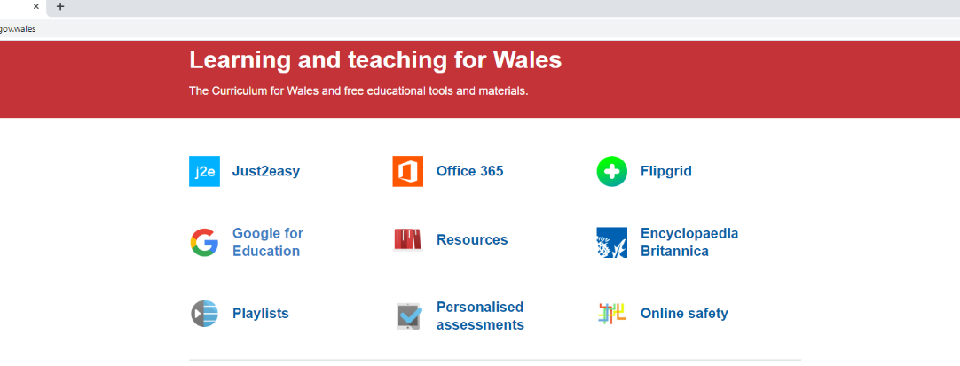
You will need to re enter your Hwb log in and password.
Once you’ve logged in you will be returned to the Home page. You will now need to select the “Google for Education” tab.

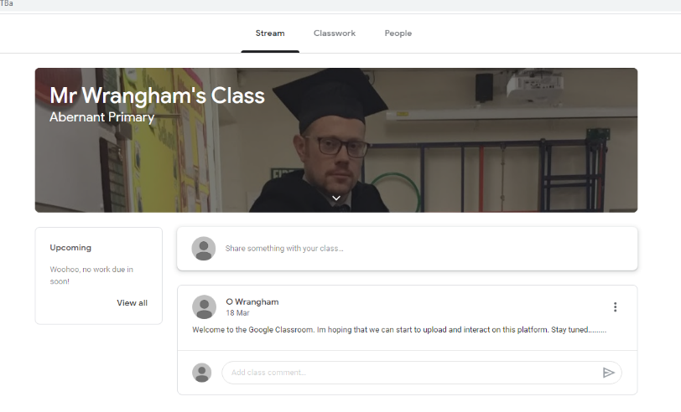
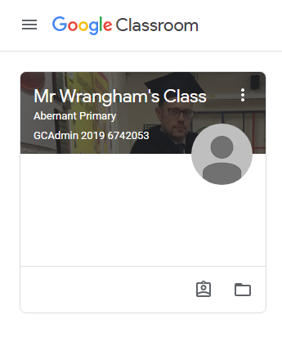
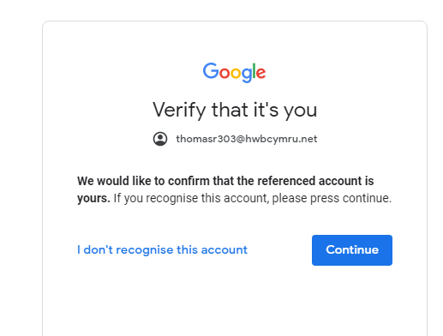
Any issues with this process or accessing the work that has been uploaded then a “comment” or “discussion” thread can be started.
If you have a question that you do not wish to share with the group you can email my work address:
Wranghamo1@hwbcymru.net.

Diolch.
When work is assigned you will find it waiting for you in the Classwork section. Instructions are included.
You should then see your class Welcome box.
Verify that you are accessing this account. You may be asked to verify your account each time you log in.

