Abernant Primary School
Policy Reviewed
Date of Review | Reviewer | Details
June 2022 | Gov. Body | 09/06/22
October 2023
October 2024
October 2025
Policy Approved
Head Teacher | Chair of Governors
Mr J. Kucia | Mr H. Davies
Date | Date
09/06/22 | 09/06/22
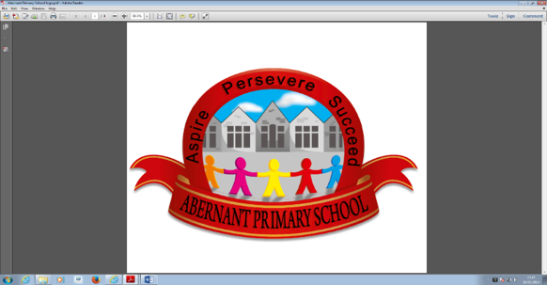
Aspire Persevere Succeed

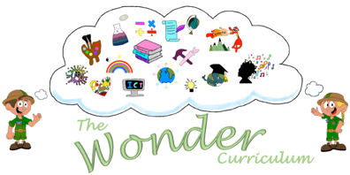

Contents

 | Page
Curriculum Definition | 2
Vision | 2
Curriculum aims | 2
Curriculum structure and design  - The four purposes  - Integral skills  - Areas of Learning and Experience (Areas)  - Statements of what matter  - Progression  - Inquiry-Based Approach (The role of disciplines in our curriculum)  - Mandatory curriculum elements  - Cross-cutting themes  - Learners’ choice  - A curriculum accessible to all  - Cynefin | 2-8
Learning and teaching | 9
Assessment | 9
Curriculum Summary | 9
Curriculum review, evaluation and revision | 9

Curriculum definition
Our school curriculum is defined as everything our learners experience in pursuit of the four purposes. It is not just what we teach but is also how we teach it and importantly, why we teach it.
Vision
At Abernant Primary our learners become confident, eager to embrace challenge and are valued for their individuality. They recognise their strengths and aspire to achieve their ambitions in a rich, dynamic and caring environment. Our learners become independent, resilient learners and make a positive contribution to society. (Article 3, 28 UNCRC).
Curriculum aims
To make our vision a reality we will:
- Foster a nurturing, inclusive environment where learners feel valued and value others.
- Promote a positive attitude towards learning, so that all learners enjoy coming to school, and acquire a solid basis for a love of lifelong learning.
- Encourage individuality and aspire to develop happy independent and resilient learners.
- Promote a Rights Respecting culture and celebrate diversity.
- Aspire our learners to be innovative and creative contributors.
- Enable our learners to realise the four purposes and equip them for ongoing learning, work and life.
- Set high expectations and enable all learns to achieve their potential.
- Teach learners the basic skills of literacy, numeracy (incorporating the Literacy and Numeracy Framework – LNF) and Digital competency Framework (DCF).
- Support our learners to critically engage with a range of information and to assess its value and validity.
- Recognise the languages, abilities, backgrounds, talents and interests of our learners to support them in their academic journey.
- Ensure our curriculum is co-constructed with all partners (learners, families, governors, all staff members and the wider community).

Curriculum Structure and Design
Four Purposes
The Four Purposes are what drive our curriculum and what we aim for our learners to be when they leave education.
Our curriculum is designed so that all learners will be supported as they develop as:
ambitious, capable learners who:
- set themselves high standards and seek and enjoy challenge,
- are building up a body of knowledge and have the skills to connect and apply,
that knowledge in different contexts
- are questioning and enjoy solving problems,
- can communicate effectively in different forms and settings, using both Welsh,
and English
- can explain the ideas and concepts they are learning about,
- can use number effectively in different contexts,
- understand how to interpret data and apply mathematical concepts,
- use digital technologies creatively to communicate, find and analyse information,
- undertake research and evaluate critically what they find,
and are ready to learn throughout their lives.
enterprising, creative contributors who:
- connect and apply their knowledge and skills to create ideas and products,
- think creatively to reframe and solve problems,
- identify and grasp opportunities,
- take measured risks,
- lead and play different roles in teams effectively and responsibly,
- express ideas and emotions through different media,
- give of their energy and skills so that other people will benefit,
and are ready to play a full part in life and work.

ethical, informed citizens who:
- find, evaluate and use evidence in forming views,
- engage with contemporary issues based upon their knowledge and values,
- understand and exercise their human and democratic responsibilities and rights,
- understand and consider the impact of their actions when making choices and acting,
- are knowledgeable about their culture, community, society and the world, now and in the past,
- respect the needs and rights of others, as a member of a diverse society,
- show their commitment to the sustainability of the planet,
and are ready to be citizens of Wales and the world.
healthy, confident individuals who:
- have secure values and are establishing their spiritual and ethical beliefs,
- are building their mental and emotional well-being by developing confidence,
resilience and empathy,
- apply knowledge about the impact of diet and exercise on physical and mental health in their daily lives,
- know how to find the information and support to keep safe and well,
- take part in physical activity,
- take measured decisions about lifestyle and manage risk,
- have the confidence to participate in performance,
- form positive relationships based upon trust and mutual respect face and overcome challenge,
- have the skills and knowledge to manage everyday life as independently as
they can,
and are ready to lead fulfilling lives as valued members of society.
Integral Skills
The four purposes are also underpinned by integral skills which will be developed through a wide range of teaching and learning within our curriculum.
Creativity and innovation
Our curriculum will be designed in a way that develops our learners’ creativity and innovation by providing the space for and the opportunities that support them to:
- be curious and inquisitive, and to generate ideas;
- link and connect disparate experiences, knowledge and skills, and see,
explore and justify alternative solutions;
- be able to identify opportunities and communicate their strategies.
This will support our learners to create different types of value.
Critical thinking and problem-solving
Our curriculum will be designed in a way that develops our learners’ critical thinking and problem solving by providing the space for and opportunities that support them to:
- ask meaningful questions, and to evaluate information, evidence and situations;
- analyse and justify possible solutions, recognising potential issues and problems;
- become objective in their decision-making, identifying and developing arguments;
- be able to propose solutions which generate different types of value.
Personal effectiveness
Our curriculum will be designed in a way that develops our learners’ personal effectiveness by providing the space for and opportunities that support them to:
- develop emotional intelligence and awareness helping them to become confident and independent;
- lead debate and discussions, helping them to become aware of the social, cultural, ethical and legal implications of their arguments;
- evaluate their learning and mistakes, helping them to identify areas for development;
- become responsible and reliable;
- be able to identify and recognise different types of value and then use that
value.
Planning and organising
Our curriculum will be designed in a way that develops our learners’ planning and organising by providing the space for and opportunities that support them to:
- set goals, make decisions and monitor interim results (where developmentally appropriate);
- reflect and adapt, as well as manage time, people and resources.
- check for accuracy and be able create different types of value.
- develop an appreciation of sustainable development and the challenges
facing humanity
- develop awareness of emerging technological advances
- confidently meet the demands of working in uncertain situations, as changing
local, national and global contexts result in new challenges and opportunities
for success
- generate creative ideas and to critically evaluate alternatives
- build their resilience and develop strategies which will help them manage their
well-being – they should be encountering experiences where they can
respond positively in the face of challenge, uncertainty or failure
- learn to work effectively with others, valuing the different contributions they
and others make – they should also begin to recognise the limitations of their own work and those of others as they build an understanding of how different people play different roles within a team.

Areas of Learning and Experience (AoLE)
Our school curriculum is designed in a way that ensures learning and teaching that encompasses all six Areas of Learning and Experiences (Areas).
- Languages, Literacy and Communication
- Mathematics and Numeracy
- Science and Technology
- Expressive Arts
- Health and Well-Being
- Humanities
All Areas have equal status within our curriculum, and it is taught in a holistic way where appropriate.
Statements of What Matter
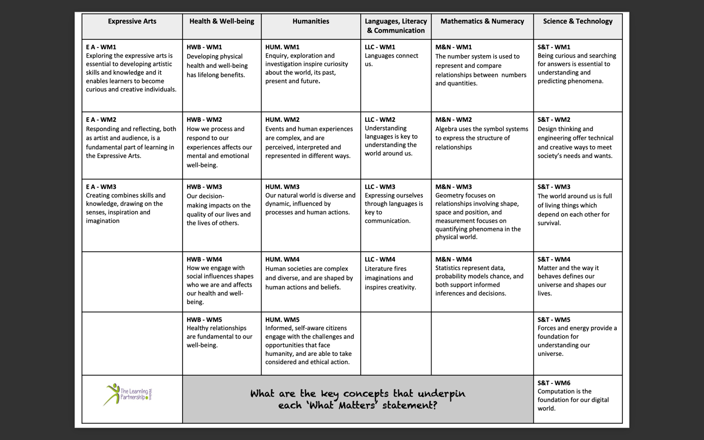
Our school curriculum provides opportunities for our learners to engage with and develop their understanding of the key concepts within all the statements of what matter.

Our curriculum uses the statements of what matter to guide the selection of all curriculum content. Specifically, they are used to:
- select the range of experiences, knowledge and skills that enable our learners to make sense of the ‘big ideas’ and key principles within each statement
- support our learners’ progression within the ‘big ideas’ and key principles and their ability to be able to develop an increasingly sophisticated understanding and application of the statements of what matter,
- allow learners to explore topics and ideas through different lenses – the same concept or idea will be explored through different statements of what matter,
- help our learners to make sense of a range of experiences, knowledge and skills within each Area by ensuring that content helps learners to develop a coherent understanding of a range of information.
Progression
Key concepts have been identified within each statement of matter and used to create progression chains to support learners on their journey. Non-negotiables for each area have been agreed upon by the cluster. As a school, we have broken the progression chains down into manageable steps, however, these are not allocated to a year group and are not a scheme of work to follow, they have been created to show the development of knowledge and skills over time and are fluid in their use rather than prescriptive. These documents are regularly evaluated and, if necessary amended, to ensure:
- Refinement and growing sophistication in the use and application of skills
- Increasing breadth and depth of knowledge
- Increasing effectiveness as a learner
- Deeping understanding of the ideas and disciplines within areas.
- Making connections ad transferring learning into new contexts
Progression is not linear and different learners are likely to progress in markedly different ways. Progression is at the heart of our curriculum design. When selecting the content of our curriculum and assessment, we use the principles of progression for each Area to inform our approach to progression.

Inquiry-Based Approach (Disciplines)
As a school, we have agreed on disciplines that require discrete teaching and those that can be taught as a focus. For the disciplines that we deem to be taught discretely, we utilise an inquiry-based approach to ensure a holistic curriculum.
What is an Inquiry-Based Approach
Inquiry-based learning is a process of learning that engages the pupils by creating real-world connections through high-level questioning and exploration. The inquiry-based learning approach encourages learners to engage in experiential learning and problem-based learning. Our inquiry approach is designed to make the exploration of the curriculum an active process of investigation where they are making conceptual connections across a range of contexts.
Benefits of an Inquiry-Based Approach
As part of the new curriculum 2020, we are ensuring our pupils are provided with opportunities to be; Ambitious, Capable Learners, Enterprising, Creative Contributors, Ethical, Informed Citizens and Healthy, Confident Individuals. This is supported through the inquiry approach:
- We provoke, model and celebrate curiosity.
- It involves the pupils in some decisions about their learning.
- Helps learners to make connections in their learning.
- It provides a real-life context for children to apply their skills and solve problems.
- Modules are designed to ensure that children are deepening their conceptual understanding through different contexts.
Nursery – Year 1
Each term, there is an overarching module that the whole school follows. However, the inquiry within each class will be focused on different concepts. Every Friday afternoon is dedicated for pupil-negotiated inquiries. Although teachers plan for an inquiry linked to the module, if learners lead them in a different direction, then responsive teaching takes place. The structure is as follows:
Noticing – Learners identify something that interests them. Adults facilitate this and observe the concepts that the learners are developing.
Make meaning – Learners are immersed in skills, knowledge and experiences that help them to understand what they have observed. Adults are here to support the learning but understand when to intervene.
Reflect to understand – Adults continue to support and observe the understanding of the learners. Learners reflect on their journey of understanding, what worked and what didn’t.
Share and explain – Learners explain what they have found out to someone new. Adults reflect, assess and summarise the learning that has taken place.
Year 2 – Year 6
Each term, there is an overarching module that the whole school follows. However, the inquiry within each class will be focused on different concepts. The structure of each inquiry will stay the same.
Central idea - For each module, children are given a central idea which is used to frame the learning.
Tuning In - Children will take part in engaging activities which will encourage pupil voice and lines of inquiry.
Finding Out - This stage takes children beyond what they already know, they are taught the relevant information and skills needed.
Sorting Out - This is a pause in the learning. Children are given time to sort, organise, represent and present information from the Tuning In and Finding Out stages. There are also opportunities for children to decide where they would like to take their learning.
Going Further - Children are given opportunities to pursue questions and interests that have arisen from the inquiry so far. They are able to work independently or co-operatively to become more expert in an aspect of the module.
Reflecting and evaluating (performance of understanding) - Children are given time to thinking about their learning, how they have learnt and why have they learnt it. Their learning is celebrated through presenting to others to deepen their understanding.
Taking Action - This is an important part of inquiry learning. Children take what they have learnt and reflect upon the implications for personal action, how can they use what they have learnt in their daily lives to become a global citizen.

Contextualising Learning and Mapping
Currently, we are mapping contexts and concepts covered a term in advance. This document will be completed by Spring 2025. Although we are mapping the contexts that will be taught, staff are aware that inquiries should be reflective of prior learning and children’s interests and talents (article 29, UNCRC).
Schemas are being developed for key concepts to ensure a cyclical curriculum where learner’s understanding is revisited and deepened throughout their time at Abernant Primary.
Mandatory Curriculum Elements
Relationships and sexuality education
Relationships and sexuality education (RSE) within our curriculum is planned using the RSE Code and is designed in a way that is developmentally appropriate, inclusive and pluralistic.
Religion, Values and Ethics (RVE)
Religion, Values and Ethics (RVE) is mandatory for all learners aged 3 – 16 and sits within the Humanities Area of Learning and Experience. RVE has been interwoven into our Humanities progression chains. Teaching and learning in RVE reflects that the religious traditions in Wales are in the main Christian while taking account of the teaching and practices of the other principal religions represented in Wales. It also reflects the fact that a range of non-religious philosophical convictions are held in Wales. RVE is planned to meet the mandatory requirements of the Humanities AoLE, and to have regard to both the statutory RVE guidance within the Humanities Area, and the Locally Agreed Syllabus. There is no right to withdraw from RVE.
Cross-curricular skills
We believe that the mandatory cross-curricular skills of literacy, numeracy and digital competence are essential for learners to be able to access knowledge. They enable learners to access the breadth of our curriculum, equipping them with the lifelong skills to realise the four purposes. These are skills that can be transferred to the world of work, enabling our learners to adapt and thrive in the modern world.
Our curriculum is designed in a way that enables learners to develop competence and capability in the cross-curricular skills and extend and apply them across all Areas.
Across our curriculum, learners will be given a range of opportunities to:
- develop listening, reading, speaking and writing skills,
- be able to use numbers and solve problems in real-life situations,
- be confident users of a range of technologies to help them function and
communicate effectively and make sense of the world,
We will use the Literacy, Numeracy and Digital Competency Frameworks to guide our approach to the development of the cross-curricular skills.
Cross-Cutting Themes
Relationships and sexuality education (RSE)
Our curriculum is designed in a way that identifies and makes authentic and meaningful links between learning within a particular Area and learning within the RSE Code.
Human Rights
We believe that learning about human rights empowers learners as rights-holders. This enables our learners to critically examine their own attitudes and behaviours and to develop skills to be ethically-informed citizens of Wales and the world, who can be advocates for their rights and the rights of others. Our curriculum incorporates opportunities for our learners to:
- learn about human rights by developing their understanding of what human rights are and where those rights have come from including. This includes developing their understanding of the UNCRC and UNCRPD.
- learn through human rights which supports our learners to develop values, attitudes and behaviours that reflect human rights.
- learn for human rights, which motivates them to social action, empowerment of active citizenship and to advance respect for the rights for all.
Diversity
We want our curriculum to recognise and celebrate the diversity that exists within the social groups within our school community, the communities we serve and society as a whole. We want our learners to be aware of the characteristics of others and treat others with compassion, empathy, understanding and equity, regardless of those characteristics. As our learners progress in our curriculum, they will become increasingly aware of a range of specific characteristics which can define our identity, including sex, gender, race, religion, age, disability and sexuality.
Our curriculum incorporates opportunities for our learners to:
- develop empathy and compassion for others,
- celebrate diverse backgrounds, values and characteristics,
- develop their own values and sense of identity,
- develop understanding of people with different beliefs and perspectives,
- challenge stereotypes.
Careers and work-related experiences (CWRE)
We believe that learning about CWRE is fundamental to developing skills for work and life. Our curriculum incorporates opportunities for CWRE that inspires our learners to:
- develop an understanding of the purpose of work in life, both for themselves and for society as a whole,
- become increasingly aware of the range of opportunities available to them, broadening their horizons,
- develop the attitudes and behaviours required to overcome barriers to employability, career management and lifelong learning,
- appreciate the increasing range of opportunities in the workplace where an ability to communicate in Welsh is important,
- explore opportunities through a variety of meaningful experiences in learning, work and entrepreneurship,
- develop resilience and the ability to be adaptable in response to the challenges, choices and responsibilities of work and life.
Local, national and international contexts
Local, national and international contexts provide key perspectives for our learners and are important in supporting them to realise the four purposes.
Our curriculum incorporates opportunities for learners to:
- develop learning through a range of places and events of significance,
- make links with the local community and organisations,
- learn about the contributions and experiences of different individuals that shape each context,
- learn about cultural diversity, values, histories and traditions that shape each context,
- understand different identities, histories, cultures, perspectives and values that shape communities and societies,
- recognise and engage with factors, influences and impacts (including economic, social and environmental impacts) locally, nationally and internationally,
- develop an authentic sense of cynefin, building knowledge of different cultures and histories, allowing them to develop a strong sense of individual identity and understanding how this is connected to and shaped by wider influences,
- draw on the stories and distinctiveness of our school’s local surroundings,
- understand their role as citizens and the structures of government which affect them in each context,
- explore, critically analyse and respond to contemporary issues and challenges affecting their lives and the lives of others through each context,
- understand sustainable development, the challenges the environment and society face and how they can engage with and make a difference on these issues supporting sustainable citizenship,
- understand contemporary Wales, providing opportunities to reflect, understand and analyse contemporary society and their engagement with it,
- recognise Wales’ diverse linguistic heritage and culture, and its connections with the rest of the world,
- recognise how our languages unlock knowledge about our literature, geography, history and their links beyond Wales,
- recognise the links between local, national and international contexts, understanding how they constantly influence each other,
- use critical analysis in each context, recognising both positive and challenging aspects within each.

Learners’ Choice
At Abernant Primary, we respect the ideas, opinions and beliefs of all children (article 12, UNCRC). We believe that the inquiries that we undertake in each class are child-negotiated in order to both teach new knowledge and skills and also to incorporate learners’ prior knowledge, talents and interests (article 29, UNCRC).
A Curriculum Accessible to all
Through the designing of our curriculum, we ensure it:
- is suitable for each learner’s age, ability and aptitude (article 23),
- takes account of each learner’s additional learning needs (ALN), if any,
- secures broad and balanced learning and teaching for each learner,
- make arrangements for assessing the ability and aptitude of learners in respect of the relevant curriculum, on entry to a school or setting, to identify the next steps in their progression and the learning and teaching needed to support that progress.
- Interventions take place for those children who are identified as needing further support. Boost sessions are for all learners as part of our universal provision.
Please see assessment section.
Cynefin
Our curriculum will instil our learners with a pride and passion in themselves, our school community, the wider community and Wales. Our curriculum will allow our learners to explore and understand the different identities, landscapes and histories that all come together locally and nationally to form their cynefin. This will allow learners to develop their own sense of identity and to understand the identities of others and make connections with people, histories and landscapes elsewhere in Wales and internationally.

Learning and Teaching
At Abernant Primary School we believe in the concept of lifelong learning and the idea that both adults and children learn new things every day. We maintain that learning should be a rewarding and enjoyable experience for everyone; it should be fun.
Through our teaching, we equip children with the skills, knowledge and understanding necessary to be able to make informed choices about the important things in their lives. We believe that appropriate teaching and learning experiences help children to lead happy and rewarding lives. We also believe in equality of opportunity to succeed for every child and our learning programmes will enable each learner to reach his / her challenging yet realistic targets. To this end we have adopted a collaborative approach.
"Education by design is a classroom dynamic that guides the thoughtful design of learning experiences for children. Children frequently work collaboratively to achieve desired results – as they develop knowledge and understanding, critical and vital habits of mind." Emotional Behavioural Development is grounded in strong values. It is standards driven. It is built on the development of effective learning communities.
We believe that education must be experiential, must nurture independence and must enable all members of each generation to develop the judgments necessary to take responsibility for: The conduct of their lives, the shaping of their societies and Global citizenship. We believe that judgment is the integration of knowledge, skills and standards of ethical behaviour that guides decisions, commitment, and action.
Throughout this, and every other curriculum-based policy, the right of every child to acquire and apply basic Skills is implicit and their entitlement to support in the acquisition of those skills is fundamental.
Assessment
Assessment is a fundamental part of the teaching and learning process at Abernant. We recognise that the interrelationship between curriculum, assessment and pedagogy is key to supporting learners to make meaningful progress in their learning. We as a school have selected the knowledge, skills and experiences that best support our learners to progress in the ways described in Curriculum for Wales. Assessment at Abernant takes many forms; diagnostic, summative and formative procedures are in place. These assessments are used to ascertain a baseline, support individual learners on an ongoing, day-to-day basis, identify, capture and reflect on individual learner progress over time and to understand group progress in order to reflect on practice. Our focus will be on identifying where the learner is in their education, their next steps and the support or challenge needed to move forward in their learning.
See our assessment policy.

Curriculum Summary
In line with the mandatory requirement for schools to publish a summary of their curriculum, a copy of our curriculum summary can be found here.

Curriculum review, evaluation and revision
Our curriculum at Abernant will be kept under review on a termly basis. Our MER cycle is a rigorous, thorough and more importantly a live document – that is adjusted after monitoring tasks, evaluations and reviews have been carried out. All staff are fully aware that the school’s curriculum will continue to evolve in order to meet the differing needs and interests of the changing cohorts of children and to meet the needs of the ever-changing world in which we live. As professionals we will continue to work, collaboratively with other regional/cluster schools and external agencies to ensure up to date and innovative practice continues. Close alignment of the School Improvement Plan, Performance Management procedures and the undertaking of high-quality professional training will be maintained and prioritized to secure further effective improvement and future success.

